+-

Chemical Reactions:

reactants, products and energy change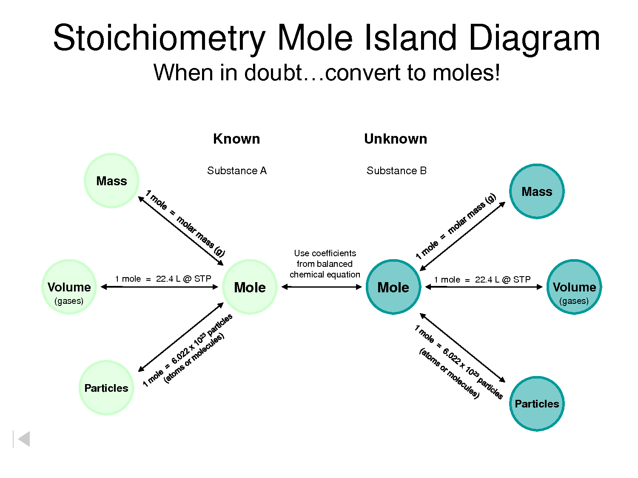

(Chemtutor n.d.)

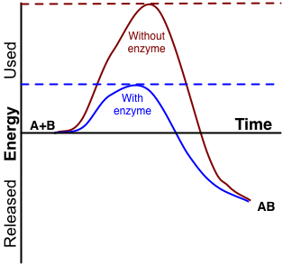

(Biochemistry/Catalysis n.d.)

| **Week** | **Outcomes** | **References** | **Tasks** |
| --- | --- | --- | --- |
| Term 2  Week 1-4 | * chemical reactions can be represented by chemical equations; balanced chemical equations indicate the relative numbers of particles (atoms, molecules or ions) that are involved in the reaction * chemical reactions and phase changes involve enthalpy changes, commonly observable as changes in the temperature of the surroundings and/or the emission of light * endothermic and exothermic reactions can be explained in terms of the Law of Conservation of Energy and the breaking of existing bonds and forming of new bonds; heat energy released or absorbed by the system to or from the surroundings, can be represented in thermochemical equations * fossil fuels (including coal, oil, petroleum and natural gas) and biofuels (including biogas, biodiesel and bioethanol) can be compared in terms of their energy output, suitability for purpose, and the nature of products of combustion * the mole is a precisely defined quantity of matter equal to Avogadro’s number of particles * the mole concept relates mass, moles and molar mass and, with the Law of Conservation of Mass; can be used to calculate the masses of reactants and products in a chemical reaction * empirical formula can be determined using percentage composition, mass composition and combustion data * the limiting reagent in a chemical reaction can be determined using masses and moles of reactants | Lucarelli p 45 Set 8  Lucarelli p 100 -108 Set 22 Q1-9  Lucarelli p 77 - 80 Set 16 Q1-5  Lucarelli p 81- 82 Set 17 Q1-12  Lucarelli p 86 - 88 Set 19 Q1-6 | STAWA Experiment 21  STAWA Experiment 35 |
| 5-7 | REVISION AND EXAMS |  |  |
|  |  |  | **Task 8: Extended response 2- Energy and CO2 output for fossil fuels and biofuels**  **Task 9: Test- Chemical Reactions: Reactants, Products and Energy Change** |

**Write balanced chemical equations of the following for more practice.**

1. Hydrogen + oxygen 🡪 water

2. Carbon + oxygen 🡪 carbon dioxide

3. Sodium + chlorine 🡪 sodium chloride

4. Potassium + oxygen 🡪 potassium oxide

5. Magnesium + oxygen 🡪 magnesium oxide

6. Magnesium + hydrochloric acid 🡪 magnesium chloride + hydrogen

7. Ammonia + water 🡪 ammonium hydroxide

8. Zinc + hydrochloric acid 🡪 zinc chloride + hydrogen

9. Sodium + sulfuric acid 🡪 sodium sulfate + hydrogen

10. Calcium carbonate + hydrochloric acid 🡪 calcium chloride + water + carbon dioxide

11. Hydrogen + nitrogen 🡪 ammonia

12. Aluminium + oxygen 🡪 aluminium oxide

13. Calcium oxide + water 🡪 calcium hydroxide

14. Calcium hydroxide + carbon dioxide 🡪 calcium carbonate + water

15. Ammonia + sulfuric acid 🡪 ammonium sulfate

16. Silver nitrate + magnesium chloride 🡪 silver chloride + magnesium nitrate

17. Potassium nitrate 🡪 potassium nitrite + oxygen

18. Sodium hydroxide + carbon dioxide 🡪 sodium carbonate + water

19. Potassium hydrogen carbonate 🡪 potassium carbonate + water + carbon dioxide

20. Zinc + silver nitrate 🡪 zinc nitrate + silver

**ENDOTHERMIC AND EXOTHERMIC REACTIONS (pg 101)**

All chemical reactions involve energy changes. Energy can be either gained or released by the reactants or products. This follows the law of conservation of energy which states that energy cannot be created or destroyed, merely converted from one form to another.

**Terms:**

* **Enthalpy (H):** the total energy (both chemical stored potential and kinetic energy) present in a substance.

1. **ΔH (enthalpy change):** difference betweenenthalpy of products and the enthalpy of reactants. The difference between the energy gained (absorbed/ taken in/ required) and the energy released. **ΔH = Hproducts  - Hreactants**

* **System:** the collection of atoms or molecules involved in a chemical reaction e.g. the ions in a precipitation reaction.
* **Surroundings:** anything around the system, but is not part of the system e.g. the solvent in a precipitation reaction, the test tube, your hand.

ENERGY PROFILE DIAGRAMS FOR EXOTHERMIC AND ENDOTHERMIC REACTIONS

The release or gain of energy can be represented in diagrams where reaction time is plotted against enthalpy. Note that total energy is always conserved, despite the change in energy of a substance as shown in these diagrams – copy from Essential Chemistry pg 114

**Exothermic Reactions**

1. More energy is released in forming bonds than is required to break the initial bonds, so the reaction releases energy to the surroundings. (Bond forming releases energy, bond breaking requires energy. The stronger the bonds that are formed, the greater the energy released in forming them.)
2. Enthalpy of products is less than reactants.
3. Reactants have a higher chemical energy than the products.
4. ΔH is negative.
5. Enthalpy decreases for the system and increases for the surroundings.
6. Energy is released from the system to the surroundings in the form of heat, light, etc.
7. The surroundings will gain heat.

**Examples of exothermic processes**

* Combustion: CH4(g) + 2O2(g) → CO2(g) + 2H2O(g) + 803 kJ **OR**

CH4(g) + 2O2(g) → CO2(g) + 2H2O(g) ΔH = – 803 kJ

* Reactions involving single atoms bond together: 2I(g) → I2(g) + 214 kJ
* Reactions in which a positive ion gains an electron: Na+(g) + e- → Na(g)
* Condensation and solidification (freezing) phase changes: I2(g) → I2(s) + 62 kJ

H2O(g) → H2O(l) ΔH = –44 kJ

* Respiration: C6H12O6(aq) + 6O2(g) → 6CO2(g) + 6H2O(l)
* Heat packs

– non-reversible: 4Fe(s) + 3O2(g) → 2Fe2O3(s) ΔH = – 1654 kJ **OR**

– reversible: NaCH3COO(aq) + 3H2O(l) ⇋ NaCH3COO.3H2O(s)

* Crystallisation

Phase changes are physical processes that involve the breaking and forming of bonds but of weak bonds only like weak intermolecular forces between iodine molecules during sublimation. By comparison chemical changes involve the breaking and forming of strong intramolecular bonds like covalent bonds in the iodine molecule. For this reason, phase changes usually involve relatively small amounts of energy compared to chemical changes.

In general, chemical processes involve greater enthalpy changes than physical processes. This is due to the fact that the intermolecular forces are usually weaker than the intramolecular forces.

**Endothermic reactions**

1. More energy is required in breaking the initial bonds than is released in forming bonds so the reaction absorbs energy from the surroundings. (Bond forming releases energy, bond breaking requires energy. The stronger the bonds that are broken, the greater the energy required to break them)
2. Enthalpy of products is greater than reactants.
3. Reactants have a lower chemical energy than the products.
4. ΔH is positive.
5. Enthalpy increases for the system and decreases for the surroundings.
6. Energy is absorbed from the surroundings to the system.
7. The surroundings will lose heat.

**Examples of endothermic processes:**

* Reactions involving a molecule breaking up: F2(g) → 2F(g)  ΔH = + 158 kJ
* Reactions in which an atom or ion loses an electron: K(g) → K+(g) + e-
* Vaporisation and liquefaction phase changes.
* Photosynthesis: 6CO2(g) + 6H2O(l) → C6H12O6(aq) + 6O2(g)
* Cold packs (older style involving ammonium nitrate dissolving in water)
* NH4NO3(s) + 126 kJ→ NH4+(aq) + NO3–(aq) **OR**
* NH4NO3(s) → NH4+(aq) + NO3–(aq) ΔH = +126 kJ

**Comparing fossil fuels: emissions and fuel values**.

**Fuel values (sometimes called heating values)**: compare the energy from the complete combustion of equal masses or volumes of different fuels. The greater the value the greater the energy available from a given mass. Units in kJ g-1, MJ kg-1, MJ L-1

x = Where $ΔHc$ = standard heat of combustion of 1 mol of the fuel. M = molar mass

**Carbon emissions**: Combustion of fuels release carbon dioxide, which is a known greenhouse gas, into the atmosphere.

**Carbon emission values**: compare the mass of carbon dioxide a given fuel produces with the amount of energy released. Units in g MJ-1.

Fill in the values for the table below from Essential Chemistry pg 105.

|  |  |  |
| --- | --- | --- |
|  | **Heating value**  **MJ.kg-1** | **Carbon emissions**  **g(CO2)MJ-1** |
| **Coal** |  |  |
| **Natural gas** |  |  |
| **LNG** |  |  |
| **lPG** |  |  |
| **Petrol** |  |  |
| **Diesel** |  |  |

**Biofuels**

Biofuels are fuels that are produced from biodegradeable materials such as crops rather than from fossil fuels. Examples of biofuels include: bioethanol, biogas and biodiesel.

**Advantages** of biofuels are that they: are made from a renewable resource, they have lower carbon emissions and they have extremely low sulphur content meaning there is no SO2 formation that can lead to acid rain.

**Bioethanol is produced** from the fermentation of plant sugars (such as in wheat and sugar cane) to ethanol by yeast.

**Biodiesel is produced** by the transesterification of oilseed crops.

#### .Significant Figures and Rounding

The rules for determining the number of significant figures are (Essential Chemistry pg 102):

**Empirical formula**

Empirical formula can be calculated using:

1. Mass data
2. Percentage composition
3. Combustion data

a) A compound was analysed and found to contain by mass 4.659 g silver and 0.347 g oxygen.

Determine its empirical formula.

b) An unidentified compound was analysed in the laboratory and found to have the following

percentage composition by mass: Carbon 26.09%, Hydrogen 4.35%, Oxygen 69.56%.

What is the empirical formula?

Also remember how to calculate percentage composition. Calculate the percentage composition of each element in Al(NO3)3.

c) A white crystalline solid of molecular formula CxHyOz was isolated from certain fruits. When

0.682 g of the compound was combusted with oxygen gas, it produced 0.968 g of carbon

dioxide gas and 0.594 g of water. Determine the empirical formula and, hence, the molecular

formula of the substance if it has a molecular mass of 62.3 g mol-1.

**Avogadro's number (N)**

Avogadro's number is **6.022 x 1023** number of particles.

For a pure substance, this is the number of particles (i.e. atoms, molecules or formula units) in **one mole** of that substance.

**The mole (mol)**

A mole of any substance is equivalent to 6.022 x 1023 particles of that substance. For a pure substance, this will be equal to its molar mass in grams.

Examples:

a) 1 mol of Mg contains 6.022 × 1023 atoms of Mg and has a mass of 24.31 g.

b) 1 mol of carbon dioxide gas (CO2) contains 6.022 × 1023 molecules of CO2 and

has a mass of 44.01 g.

c) 1 mol of NaCl contains 6.022 × 1023 formula units of NaCl and has a mass of

58.44 g.

The relationship between the number of moles of a substance (n), its mass (m) and the molar mass (M) is:

**n = m/M**

**Stoichiometry**

A balanced chemical equation is based on the principle of the **Law of Conservation of Mass.**

The law states that in a chemical reaction, matter cannot be created or destroyed. The mass of the reactants before the reaction will equal the mass of the products after the reaction, or the number of atomsof each element is the same on both sides of the equation.

The balanced chemical equation shows the number of particles of each species that reacts or is produced. Because a mole is directly proportional to the number of particles then the coefficients in a balanced equation give the ratio in which each species reacts or is produced. We call this the mole ratio and it can be calculated using the following formula:

**nu = nk x u/k**

where: nU = number of moles of unknown species

nk = number of moles of known species

u= coefficient of unknown species

k = coefficient of known species

**Limiting reagent**

We have learned how to work out the moles and masses which react in a chemical equation when one of the reactants is already known. However, many times when two reactants are added together, there is not enough of one to completely react with the other reactant.

Eg If you had 32 g of a magnesium metal and only had a very small volume of dilute acid for it to react with then not all of the magnesium will react and you would have some left over at the end.

In this case, the limiting reagent is the acid and the excess reagent is the magnesium.

The limiting reagent will affect the amount of the other reactants used and the amount of products produced.

*Eg. Which reactant would be the limiting reagent in the following? Explain why.*

2Mg + O2 → 2MgO

1. 1 mol of each
2. 2 mol Mg, 1 mol O2
3. 1 mol Mg, 2 mol O2
4. 3.7 mol Mg, 2.4 mol O2

**Mole Constituents**

|  |  |
| --- | --- |
| 1 mol HNO3 contains:  _________________________ mol H atoms  _________________________ mol N atoms  _________________________ mol O atoms | 1 mol Cu(NO3)2 contains:  ________________________ mol Cu atoms  ________________________ mol N atoms  ________________________ mol O atoms |
| 1 mol sulphur dioxide contains:  ________________________ mol S atoms  _______________________ mol O atoms | 1 mol barium nitrate contains:  _______________________ mol Ba atoms  _______________________ mol N atoms  _______________________ mol O atoms |
| 1 mol (NH4)2SO4 contains:  ________________________ mol N atoms  ________________________ mol H atoms  ________________________ mol S atoms  ________________________ mol O atoms | 5.6 mol (NH4)2SO4 contains:  ________________________ mol N atoms  ________________________ mol H atoms  ________________________ mol S atoms  ________________________ mol O atoms |
| 3 mol KNO3 contains:  ________________________ mol K atoms  ________________________ mol N atoms  ________________________ mol O atoms | 7.2 mol Ca(OH)2 contains:  __________________________ mol Ca atoms  _________________________ mol O atoms  __________________________ mol H atoms |
| 0.24 mol ZnCl2 contains:  ___________________________ mol Zn atoms  ___________________________ mol Cl atoms | 0.8 mol PbSO4 contains:  ____________________________ mol Pb atoms  ___________________________ mol S atoms  ___________________________ mol O atoms |

1. Complete the table below:

|  |  |  |  |  |  |  |
| --- | --- | --- | --- | --- | --- | --- |
| Name | Symbol/  Formula | Molar mass (M)  (g mol-1) | Number of moles (n)  (mol) | Mass (m)  (g) | Number of particles (N) | Mass of one particle  (g) |
|  | Zn |  |  |  | 5.15 x 1023 atoms |  |
| Sulfur trioxide |  |  | 2.74 |  |  |  |
| Lead (II) nitrate |  |  |  | 186.35 |  |  |

1. Calculate (showing all working) the **number of moles** of the following:
2. 876.2g of MnBr2
3. 93.4g of Cr(NO2)3
4. Calculate (showing all working) the **mass** of:
5. 5.000 moles of aluminium bromide(A*l*Br3).
6. 10.00 moles of calcium nitrate (Ca(NO3)2).

1. Nitrogen gas reacts with hydrogen gas to produce ammonia gas according to the following reaction:

N2(g) + 3H2(g) → 2NH3(g)

If 2 moles of nitrogen gas reacts, calculate (showing all working):

1. The number of moles of hydrogen gas reacted.
2. The number of moles of ammonia gas produced.
3. 3.5 mole of tin reacts according to the following reaction:

3 Sn(s) + 16HNO3*(aq)* → *3 Sn(NO3)4(aq) + 4NO(g) + 8 H2O(l)*

Calculate:

1. The mass of nitric acid that reacts.
2. The mass of water produced.
3. 32.7 g of aluminium is reacted with 131 g of chlorine to produce aluminium chloride.

Determine:

1. The limiting reagent.
2. The mass of aluminium chloride produced.
3. The mass of excess reagent left over.
4. 0.035 moles of HCI reacts with 2.5 g of CaCO3. How many moles of CO2 are formed?
5. In **3 mol of Ca3(PO4)2**,what are the number of moles of the following;

|  |  |  |  |  |
| --- | --- | --- | --- | --- |
| Particle | Ca 2+ ions | PO43- ions | P atoms | O atoms |
| n |  |  |  |  |

1. Calculate the number of moles of O atoms in 986.5g of Fe(HSO4)3

# Bibliography

*Biochemistry/Catalysis.* n.d. http://en.wikibooks.org/wiki/Biochemistry/Catalysis (accessed May 5, 2015).

Brown, J. "Science." *Pintrest.* nd. https://www.pinterest.com/julsb98/science/ (accessed February 26, 2015).

*Chemtutor.* n.d. http://www.chemtutor.com/mols.htm (accessed May 05, 2015).

Life in Research. "Life in Research Cartoon #21." *Vadlo Life Sciences Search Engine.* 2008. http://vadlo.com/cartoons.php?id=21 (accessed February 26, 2015).

Lucarelli, Nick. *Essential Chemistry Units 1 + 2.* 1. Willeton, WA: Lucas Publications, 2015.

NA. "Chemsirty Cat Meme Generator." *Pics & photos.* 2014. http://funny-pictures.picphotos.net/chemistry-cat-meme-generator-diy-lol510/assets.diylol.com*hfs*6f8*5a9*51e*resized*chemistry-cat-meme-generator-a-covalent-bond-yells-at-an-ionic-bond-didn-t-anybody-ever-teach-you-to-share-3ad3fd.jpg/ (accessed February 26, 2015).

Snorgtees. "The NAme's Bond, Ionic Bond." *Snorg Tees.* nd. http://www.snorgtees.com/the-name-s-bond-ionic-bond (accessed February 26, 2015).